# Target Metrics

Overall - Accuracy: 0.3100, Precision: 0.8375, Recall: 0.3100, F1: 0.4065

Class-specific metrics:

Carbon neutral(ity) - Precision: 0.8000, Recall: 0.3200, F1: 0.4571

Emissions reduction target - Precision: 0.9000, Recall: 0.3600, F1: 0.5143

N/A - Precision: 0.0000, Recall: 0.0000, F1: 0.0000

Net zero - Precision: 0.6500, Recall: 0.5200, F1: 0.5778

No target - Precision: 1.0000, Recall: 0.0400, F1: 0.0769

# Year Metrics

Overall - Accuracy: 0.6100, Precision: 0.6004, Recall: 0.6100, F1: 0.6032

Class-specific metrics:

- Precision: 0.0000, Recall: 0.0000, F1: 0.0000

2020 - Precision: 0.0000, Recall: 0.0000, F1: 0.0000

2022 - Precision: 0.0000, Recall: 0.0000, F1: 0.0000

2023 - Precision: 0.0000, Recall: 0.0000, F1: 0.0000

2025 - Precision: 0.5000, Recall: 0.6000, F1: 0.5455

2030 - Precision: 0.8148, Recall: 0.8800, F1: 0.8462

2031 - Precision: 0.0000, Recall: 0.0000, F1: 0.0000

2031-32 - Precision: 0.0000, Recall: 0.0000, F1: 0.0000

2032 - Precision: 0.0000, Recall: 0.0000, F1: 0.0000

2033 - Precision: 0.0000, Recall: 0.0000, F1: 0.0000

2035 - Precision: 0.8333, Recall: 1.0000, F1: 0.9091

2040 - Precision: 1.0000, Recall: 0.8000, F1: 0.8889

2050 - Precision: 0.8519, Recall: 0.8519, F1: 0.8519

2060 - Precision: 0.0000, Recall: 0.0000, F1: 0.0000

No target - Precision: 0.0000, Recall: 0.0000, F1: 0.0000

Unknown - Precision: 0.0000, Recall: 0.0000, F1: 0.0000

designated year - Precision: 0.0000, Recall: 0.0000, F1: 0.0000

# Other Metrics

Quote Accuracy: 0.3800

Overall Accuracy: 0.2700

Valid XML Percentage: 1.0000

# Confusion Matrices

Target Confusion Matrix:

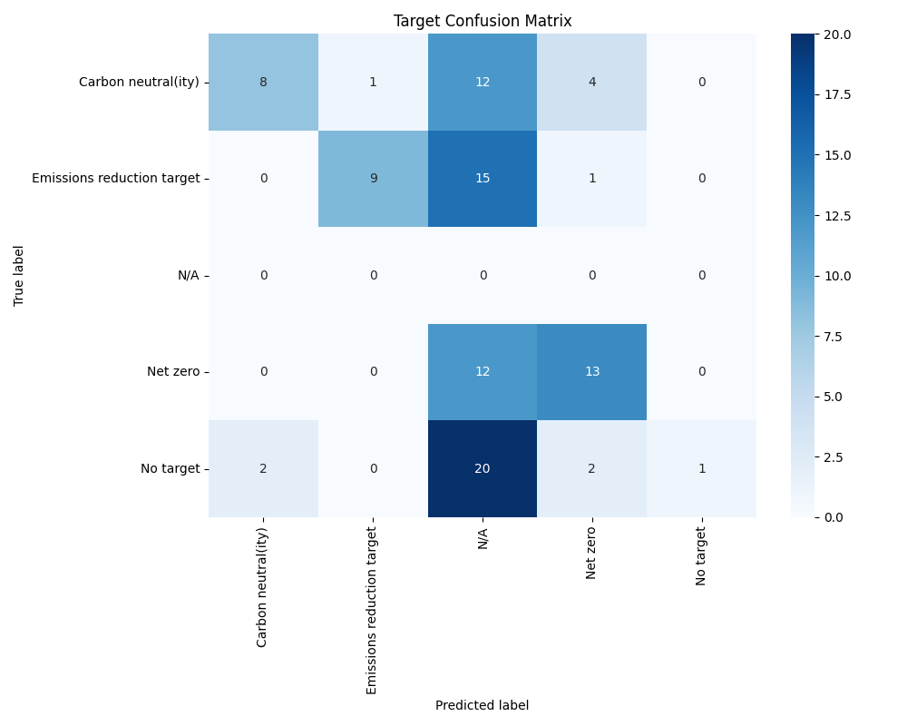

Year Confusion Matrix:

